**Medical Informatics (BIOM9450)**

**Tutorial 5 (assignment No. 3): Client-Side Form Validation Using JavaScript**

***Due***

Submit all source code along with a written report as a single .zip file to Moodle. Your written report should contain screen shots of any validation alerts generated by your code as well as highlight the most important parts of your well commented code (in particular your validation of form input), and a description of your design choices and what motivated them.

# Objectives

To incorporate JavaScript client-side form validation in the webpage implemented in Tutorial 4.

# Background

In this tutorial you are required to implement a registration form at the bottom of the webpage you designed for the fictitious workshop website in Tutorial 4. The code will be used to implement client-side form validation, so that only valid form data is submitted when the potential delegate wishes to register.

# Tasks

Add JavaScript code to the HTML page you implemented in Tutorial 4 in order to register a potential workshop delegate (see Figure 1).

You should request from the user their email address, and a password (which must be entered twice), their first and last names, date of birth in the specified format, gender (dropdown menu), and a check box to indicate if they would like to receive marketing material.

You must perform the following form validations on the text entered:

* Once the focus moves away from a text field (hint: use JavaScript event onChange) you should immediately validate the text entered; if the text entered is invalid you should display an error message beside the form text field to inform the user how to complete it correctly (see Figure 2).

<input type="text" id="dob" name="dob" maxlength="10" size="19" value="" onChange="validDateOfBirth(this, 'Date of birth')">

* On submission of an invalid form (by clicking the ‘Register button in Figure 1), you must prompt the user with an alert popup reminding them to address the errors in the form before submitting.

<input type="submit" id="submit" value="Register now!">

* On submission of a valid form (by clicking the ‘Register now!’ button in Figure 1), you should use the GET HTML method for this tutorial to direct the user to a new page which confirms that their registration was successful. (The example in Figure 4 also displays the information entered using PHP, but you do not need to do this for this tutorial; a static confirmation webpage will do fine.)

<form id="registrantInfo" onSubmit="return validInfo()" method="GET" action="regSuccess.html">

* + In later lecture we will use the POST HTML command to send information for processing to another PHP page, rather than a static HTML page.

The requirements for the text in each of the form element text fields to be valid are as follows:

* Email address should be valid. The official rules on email validation are complicated (see: [http://en.wikipedia.org/wiki/Email_address#Syntax](http://en.wikipedia.org/wiki/Email_address%23Syntax)), but you can use the following simplified rules:
  + Before the ‘@’ you can have any number of a-z, A-Z, 0-9, ‘.’, ‘_’, or ‘-’
  + After the ‘@’ you can have any number of a-z, A-Z, 0-9, ‘.’, or ‘-’
  + At the end you can have a ‘.’ followed by between 2 and 4 characters from a-z or A-Z
* Password must contain at least 8 characters, and include uppercase, lowercase, and numerical characters
* Re-enter password must match the password entered above
* ‘First name’ and ‘Last name’ values may contain any characters in the set [a-zA-Z], or white space characters, or apostrophes (such as might be seen in the name “O’Brien”), or hyphens (e.g. “Taylor- McKenzie”), but must not contain any other character types.
* Date of birth must be entered as text in the format ‘dd/mm/yyyy’. **You are not allowed to use a date picker.** You perform some checking that the day, month and year are realistic (can exist, and not a future date, or several hundred years ago).

Fig. 1. Empty registration form

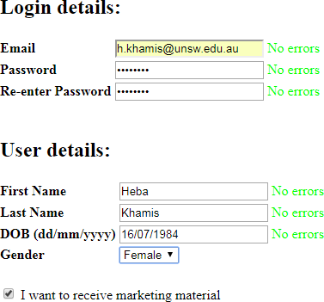

Fig. 2. Correctly completed registration form

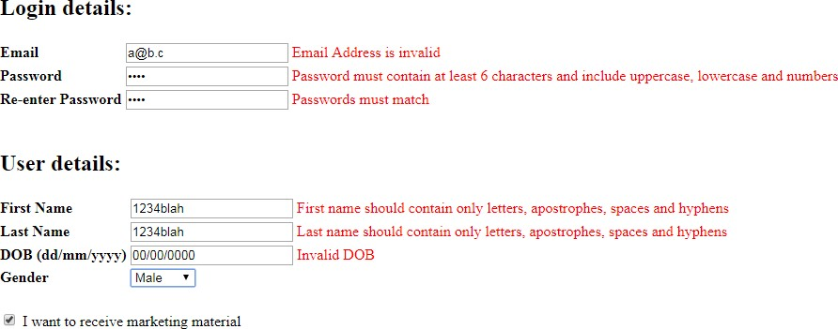

Fig. 3. Incorrectly completed registration form. Error messages are displayed as soon as the user removes the focus from the text field.



Fig. 4. Possible confirmation page. In this example the details are dynamically added to the response page using PHP. For this tutorial, you can simply use a page which has static text.

**Evaluation Criteria:**

Accuracy and clarity of information presented.

Effective use of HTML and JS codes and structures.

Visual appeal and professionalism of the webpage design.

Navigability and functionality of links and buttons on the webpage.

Adherence to assignment instructions and submission guidelines.

Endeavor to proofread your work carefully before submission.

Good luck! 😊

BIOM9450 Team